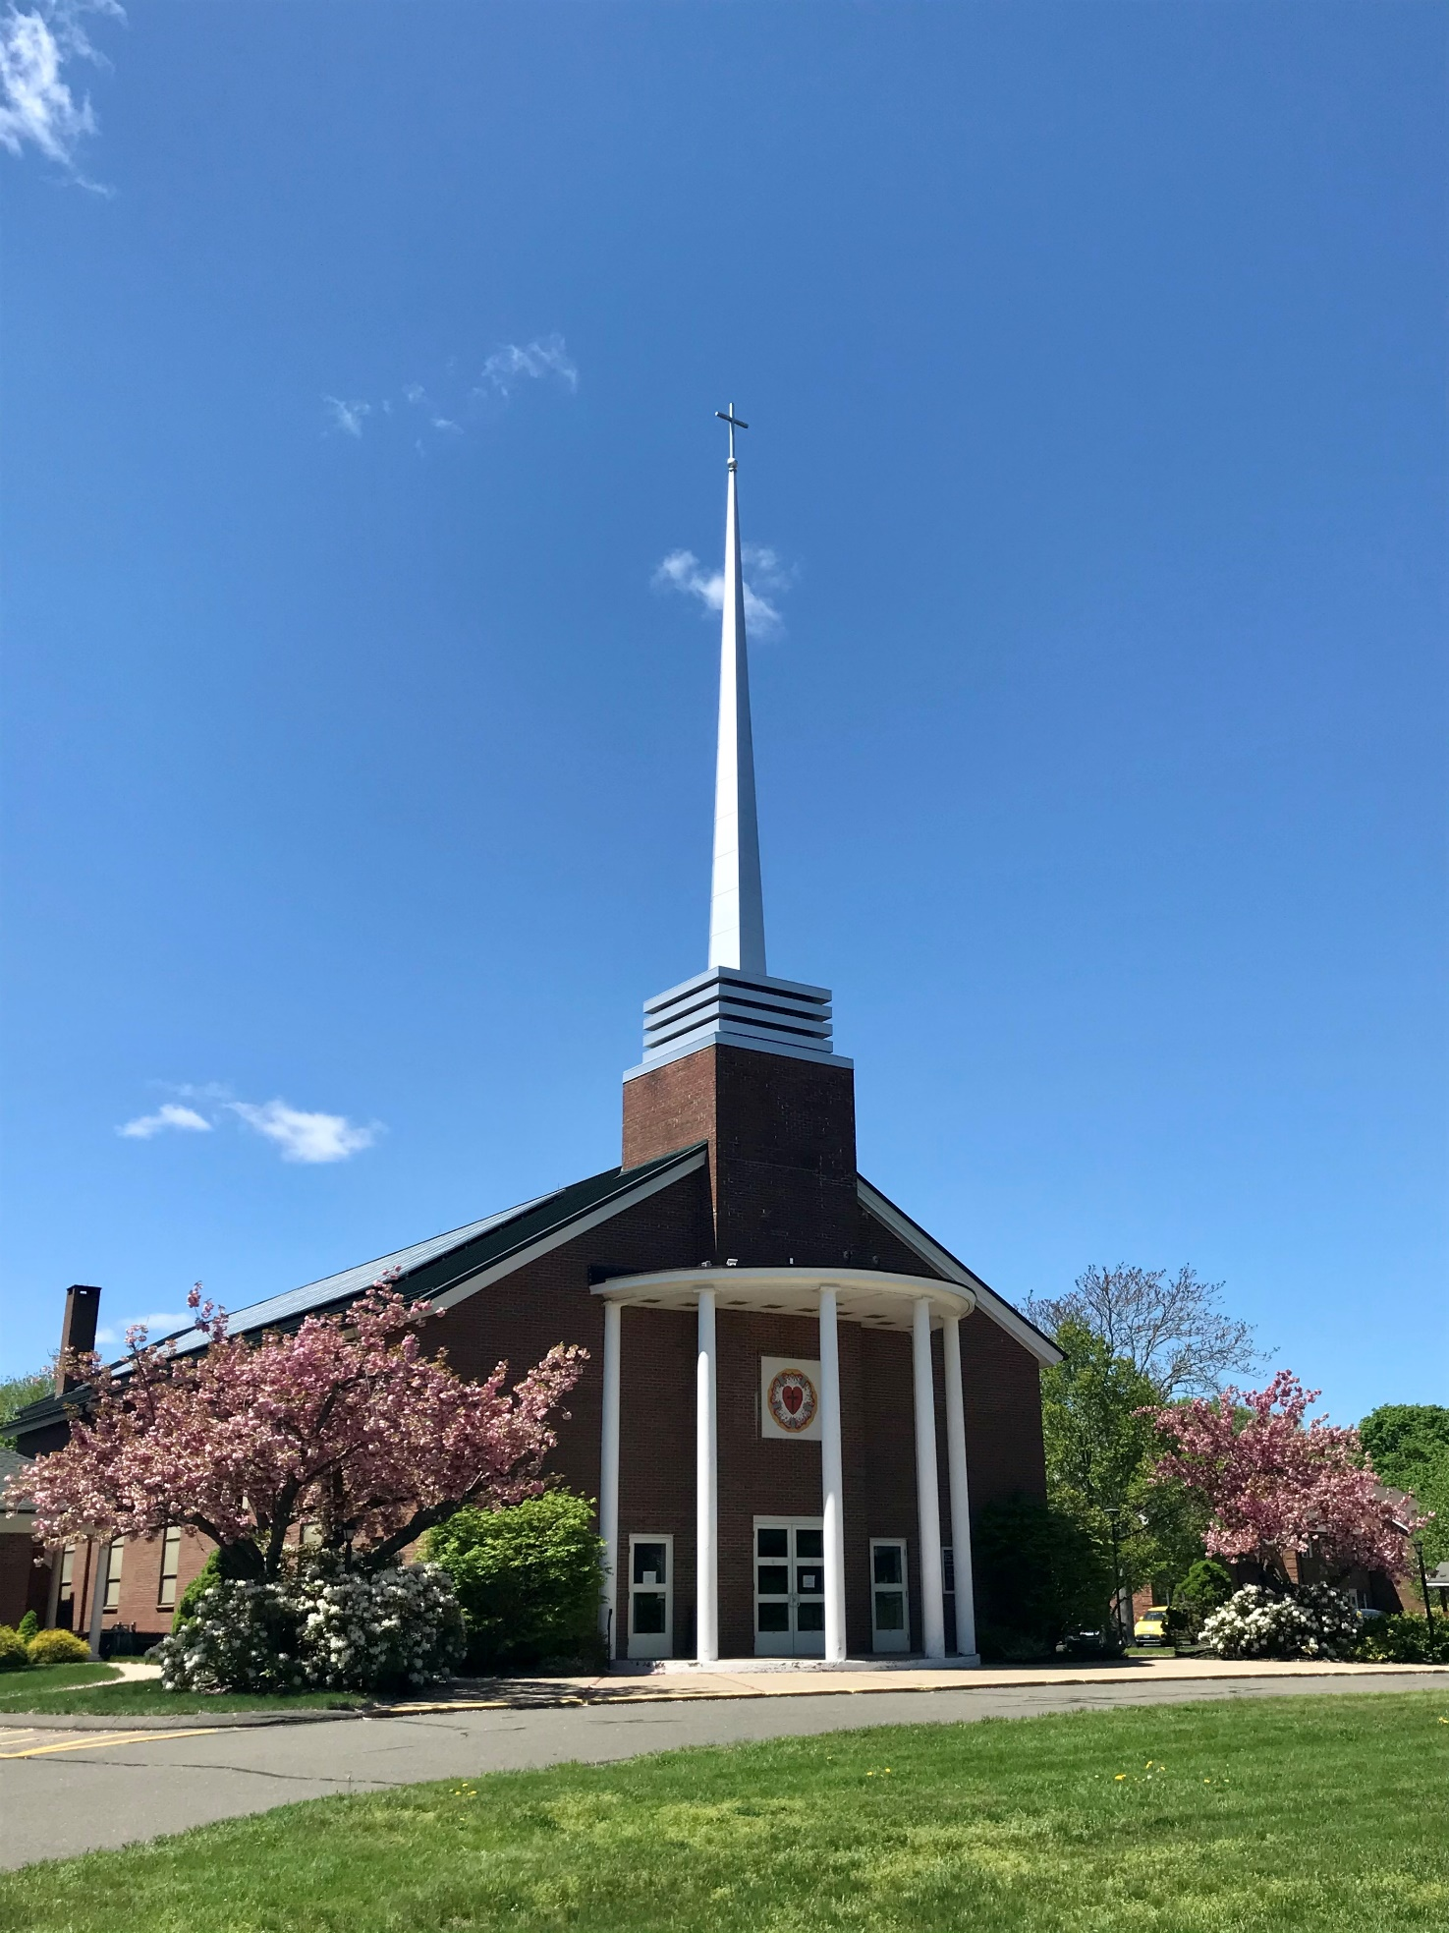
Concordia Lutheran Church 40 Pitkin Street, Manchester, Connecticut

Celebration of Ministry Eucharist
June 7, 2026

Thanksgiving for Baptism
Introduction
We gather at this Eucharist to celebrate Concordia Lutheran Church as we conclude 132 years of ministry in the Town of Manchester.
With recognition to our pastors and ministers of music, for decades Concordia has been a "singing" congregation with a deep and abiding appreciation for the Lutheran liturgy.
And so, it is appropriate on this day, that this liturgy is crafted specifically to be reflective of Concordia's love of music and liturgy. It is meant to be festive and celebratory as we give thanks to God for all the ways that Concordia has been able not only to serve its members, but also the Manchester community and beyond.
In today's Second Lesson we read this in St. Paul's letter to the Church at Corinth:
"But we have this treasure in clay jars, so that it may be made clear that this extraordinary power belongs to God and does not come from us."
This is a reminder that all that Concordia has been is not because of the goodness and works of members past and present, but rather because of God who has guided, supported and worked through us to do this work in God's kingdom.
Thanks be to God!
Let's celebrate!

Prelude - Toccata in F Major – Johann Sebastian Bach
Limina Luminis “Threshold of Light”– Olivia Belli
John Anderson, Organ

Welcome - Mark L. Winzler, President - Congregation Council

Greeting - The Rev. Nathan D. Pipho, Bishop - New England Synod

All stand as able and face the rear of the church.

In the name of the Father, and of the + Son, and of the Holy Spirit. Amen.
Friends, we gather around these waters of baptism as we remember the Christ who meets us at the beginning, who walks with us in the middle, and who calls us home at the end.

O God at the beginning, you create us, you redeem us, and you sustain us and your whole creation. We bless you for these waters that have washed generations of your children in this place. We praise you for those who have lived out their baptismal call within this congregation, for our pastors, deacons, catechists, church workers, musicians, choir members, and Sunday School teachers. For outreach ministers, nursery school teachers, fellowship coordinators, groundskeepers, prayer leaders, visitors to the sick and suffering, florists, cooks, gardeners, cleaners, justice workers, advocates for peace, financial overseers, audio technicians, boiler maintainers, and parking lot snow plowers. For these and all your gifts we praise you.
O God at the beginning, we praise you for the birthing waters of this font.
O God who walks with us in the middle, we praise you for your guiding and providential hand throughout generations of your people in this congregation. We praise you for the gift of each child, each ministry, each heart made new through forgiveness and peace, for each hungry mouth fed at your table of love and for the willing hands you have sent forth in service to the sick, the vulnerable, and those who grieve. In the middle, we have often fallen, made wrong choices, left things undone, and not been attentive to your voice. But you have not abandoned us, rather, you have sought us out, called us to new ways, and plunged us again into your living waters of life. For these and all your gifts we bless you.
O God in the middle, we bless you for the sustaining and renewing waters of this font.
O God at the end, you forgive, you heal, you reconcile, and you embrace us with everlasting cords of love and grace. We offer thanksgiving to you, even and especially at the end, for you have promised to meet us even here, when the future seems uncertain and the path before us appears untrodden. We give you praise that your mercies are new every morning, so great is your faithfulness. Continue to make of us a new creation, continue to create in us clean and new hearts, continue to re-new a right spirit within us, and, through your grace, restore unto us the joy of your salvation. For these and all your gifts we adore you.
O God at the end, we adore you for the waters that welcome us home again.
Gracious God, as these waters which meet us at the beginning, the middle, and the end are showered upon us, lift us from dull despair and continue to call us to that new and eternal banquet where all of creation will be gathered, at long last, around your providential table.
O God at the beginning, O God in the middle, O God at the end,
We praise you, we bless you, and we adore you. Amen.
The assembly is sprinkled with the baptismal waters as a remembrance of their baptism into Christ’s death and resurrection.
Gathering Hymn A Mighty Fortress

Congregation- verses 1,2,4 Choir Alone – verse 3 ELW 504

Greeting
The grace of our Lord Jesus Christ, the love of God, and the communion of the Holy Spirit be with you all.
And also with you.
Kyrie

Hymn of Praise This Is the Feast

Prayer of the Day
The Lord be with you. And also with you.
Let us Pray.
Most High God, whom the heavens cannot contain, we give you thanks for the gifts of those who built this house of prayer to your glory; we praise you for the fellowship of those who have made it holy; and we give thanks for all who have sought and found you here and were filled with joy and peace. Grant that we may ever follow in the way, the truth, and the life, Jesus Christ, our Savior and Lord. Amen.
All are seated.
First Lesson Isaiah 40: 1-2, 6-8
¹ Comfort, O comfort my people, says your God. ² Speak tenderly to Jerusalem, and cry to her that she has served her term, that her penalty is paid, that she has received from the Lord’s hand double for all her sins. ⁶ A voice says, “Cry out!” And I said, “What shall I cry?” All flesh is grass; their constancy is like the flower of the field. ⁷ The grass withers; the flower fades, when the breath of the Lord blows upon it; surely the people are grass. ⁸ The grass withers; the flower fades, but the word of our God will stand forever.
The Word of the Lord. Thanks be to God.
Choir Anthem Draw Us In the Spirit’s Tether Harold Friedell
Draw us in the Spirit’s tether, for when humbly, in thy name,
two or three are met together, Thou art in the midst of them.
Alleluia! Alleluia! Touch we now thy garment’s hem.
As disciples used to gather in the name of Christ to sup,
then with thanks to God the Father, break the bread and bless the cup,
Alleluia! Alleluia! So knit thou our friendship up.
All our meals and all our living make as sacraments of thee,
that by caring, helping, giving, we may true disciples be.
Alleluia! Alleluia! We will serve Thee faithfully.
Second Lesson 2 Corinthians 4: 7-9, 16-18

⁷ But we have this treasure in clay jars, so that it may be made clear that this extraordinary power belongs to God and does not come from us. ⁸ We are afflicted in every way but not crushed, perplexed but not driven to despair, ⁹ persecuted but not forsaken, struck down but not destroyed, ¹⁶ So we do not lose heart. Even though our outer nature is wasting away, our inner nature is being renewed day by day. ¹⁷ For our slight, momentary affliction is producing for us an eternal weight of glory beyond all measure, ¹⁸ because we look not at what can be seen but at what cannot be seen, for what can be seen is temporary, but what cannot be seen is eternal.
The Word of the Lord.
Thanks be to God.
All stand as able.
Gospel Acclamation Halle, Halle, Hallelujah
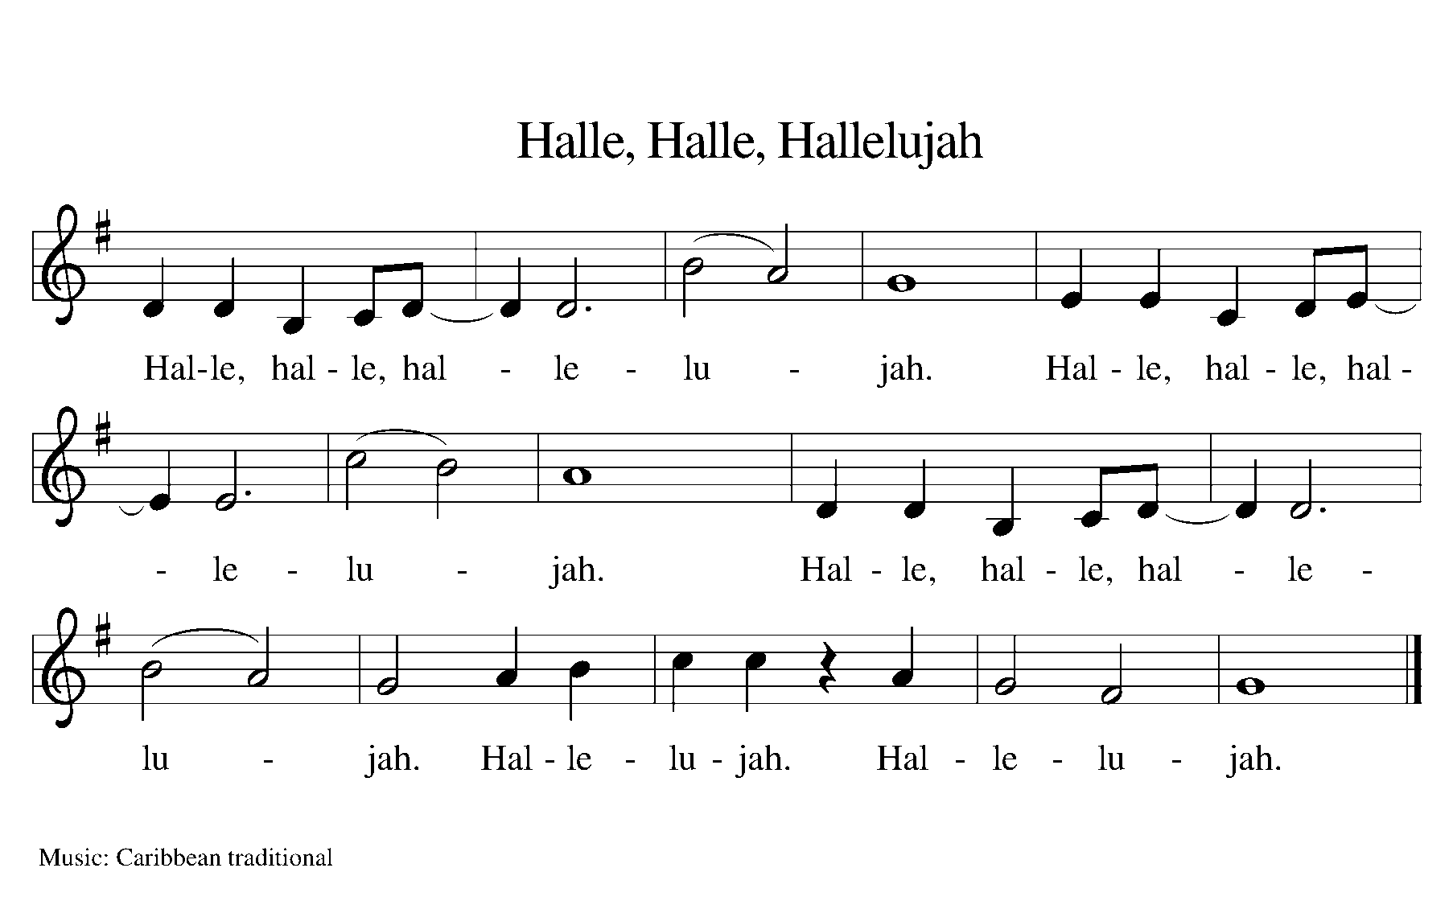

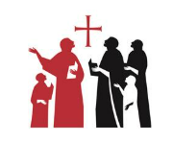

Holy Gospel Matthew 25: 31-46
The Holy Gospel according to Saint Matthew.
Glory to you, O Lord.
³¹ “When the Son of Man comes in his glory and all the angels with him, then he will sit on the throne of his glory. ³² All the nations will be gathered before him, and he will separate people one from another as a shepherd separates the sheep from the goats, ³³ and he will put the sheep at his right hand and the goats at the left. ³⁴ Then the king will say to those at his right hand, ‘Come, you who are blessed by my Father, inherit the kingdom prepared for you from the foundation of the world, ³⁵ for I was hungry and you gave me food, I was thirsty and you gave me something to drink, I was a stranger and you welcomed me, ³⁶ I was naked and you gave me clothing, I was sick and you took care of me, I was in prison and you visited me.’
³⁷ Then the righteous will answer him, ‘Lord, when was it that we saw you hungry and gave you food or thirsty and gave you something to drink? ³⁸ And when was it that we saw you a stranger and welcomed you or naked and gave you clothing? ³⁹ And when was it that we saw you sick or in prison and visited you?’ ⁴⁰ And the king will answer them, ‘Truly I tell you, just as you did it to one of the least of these brothers and sisters of mine, you did it to me.’ ⁴¹ Then he will say to those at his left hand, ‘You who are accursed, depart from me into the eternal fire prepared for the devil and his angels, ⁴² for I was hungry and you gave me no food, I was thirsty and you gave me nothing to drink, ⁴³ I was a stranger and you did not welcome me, naked and you did not give me clothing, sick and in prison and you did not visit me.’ ⁴⁴ Then they also will answer, ‘Lord, when was it that we saw you hungry or thirsty or a stranger or naked or sick or in prison and did not take care of you?’ ⁴⁵ Then he will answer them, ‘Truly I tell you, just as you did not do it to one of the least of these, you did not do it to me.’ ⁴⁶ And these will go away into eternal punishment but the righteous into eternal life.”
The Gospel of the Lord.
Praise to you, O Christ.
All are seated.
Sermon The Reverend JoAnn A. Post

All stand as able.

Hymn of the Day Love Divine, All Loves Excelling ELW 631
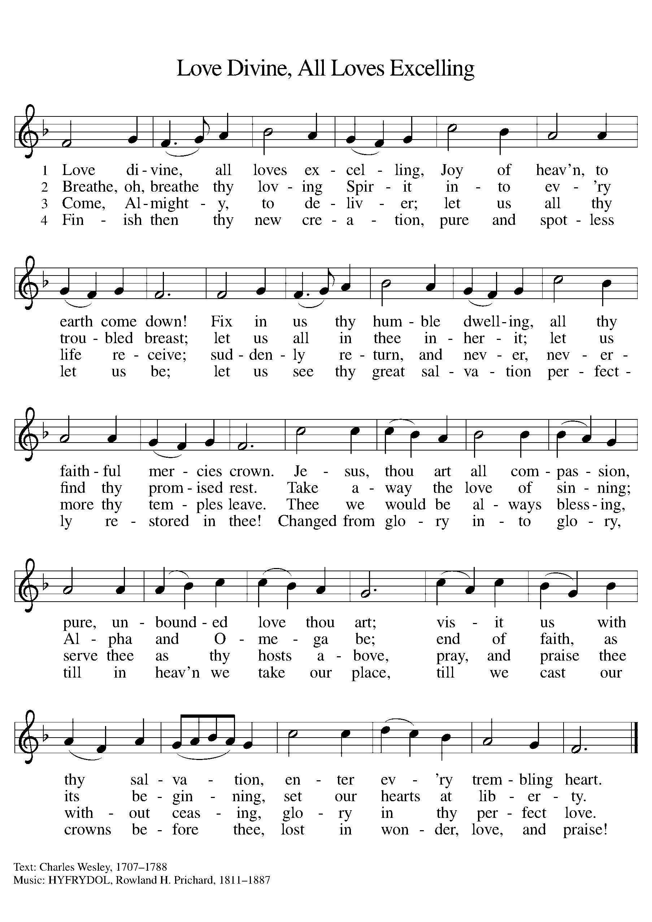

Nicene Creed

We believe in one God, the Father, the Almighty, maker of heaven and earth, of all that is, seen and unseen.
We believe in one Lord, Jesus Christ, the only Son of God, eternally begotten of the Father, God from God, Light from Light, true God from true God, begotten, not made, of one Being with the Father; through him all things were made. For us and for our salvation he came down from heaven, was incarnate of the Holy Spirit and the virgin Mary and became truly human.
For our sake he was crucified under Pontius Pilate; he suffered death and was buried.
On the third day he rose again in accordance with the scriptures; he ascended into heaven and is seated at the right hand of the Father. He will come again in glory to judge the living and the dead, and his kingdom will have no end.
We believe in the Holy Spirit, the Lord, the giver of life, who proceeds from the Father and the Son, who with the Father and the Son is worshiped and glorified, who has spoken through the prophets. We believe in one holy catholic and apostolic church. We acknowledge one baptism for the forgiveness of sins. We look for the resurrection of the dead, and the life of the world to come. Amen.

Prayers of Intercessions
Gathered together by the Holy Spirit, let us pray for the Church and the needs of the world.
We pray for the Church throughout the world. May all Christians hunger for the bread of life that we may be transformed into the Body of Christ. We pray for all church leaders especially our Bishops Yehiel and Nathan, that through their example, we too may follow more closely in the path that leads to you.
God of Grace…… Hear our Prayer.
Look in mercy upon the nations of the world and grant them peace especially in Ukraine, Israel, Palestine, Iran and also here in the United States. Give the spirit of wisdom and understanding to all who rule. Banish all vain ambition and love of power. Let your spirit prevail that all may learn to love one another, bearing each other’s burdens.
God of Grace…… Hear our Prayer.
Uphold and comfort those in need of the reassurance of your presence in their lives: the oppressed and the rejected, those experiencing difficulties, those burdened with anxiety, those facing trials of their faith, the sick, the suffering, and those in mourning and those whom we now name either silently or aloud.
God of Grace…… Hear our Prayer.

In this our 132nd and last year of witness in the Town of Manchester, we ask you to remind us of the faith and testimony of those who have gone before us in the faith and in the history of Concordia as they have bestowed a godly heritage on us. Like them, preserve us in your mercy and keep us in the unity of the Spirit. And, as you extended loving kindness to them in their failures and weaknesses, forgive us as well.
God of Grace…… Hear our Prayer.
We thank you that you have surrounded us with a great company of saints who have gone before us:
- apostles and martyrs,
- reformers and renewers of the Church especially Martin Luther,
- saints of our time who sought to restore the unity of the body of Christ;
- and all who remained steadfast to your word in their lives.
Grant us all grace to learn and to act now, following their example; so that we, like they, shall see your face and enjoy your eternal peace.
God of Grace…… Hear our Prayer.
Trusting you receive all our prayers, we commend our spoken and unspoken prayers to you, O God, through Jesus Christ, our Savior. Amen.
Exchange of Peace
The risen Christ came and stood among his disciples and said, ‘Peace be with you.’
Then were they glad when they saw the Lord. Alleluia.
The peace of Christ be with you always. And also with you.
All are seated.

Choir Anthem Thy Will Be Done (Dein Will Gescheh’)
from “St. John Passion”, Johann Sebastian Bach
Our Father, Thou in heav'n above,
Who biddest us to dwell in love,
As brethren of one family,
And cry for all we need to Thee;
Teach us to mean the words we say,
And from the inmost heart to pray.

Thy kingdom come! Thine let it be
In time and in eternity!
O let Thy Holy Spirit dwell
With us, to rule and guide us well;
From Satan's mighty pow'r and rage
Preserve Thy Church from age to age.
Amen! That is, so shall it be!

Strengthen our faith and trust in Thee
That we may doubt not, but believe
That what we ask we shall receive.
Thus in Thy name and at Thy word
We say: "Amen. Now hear us, Lord."

All stand as able.

Offertory Prayer
Let us Pray.
Blessed are you, O God, maker of all things.
Through your goodness you have blessed us with these gifts:
ourselves, our time, and our possessions.
Use us, and what we have gathered,
in feeding the world with your love,
through the one who gave himself for us,
Jesus Christ, our Savior and Lord.
Amen.

The Dialogue
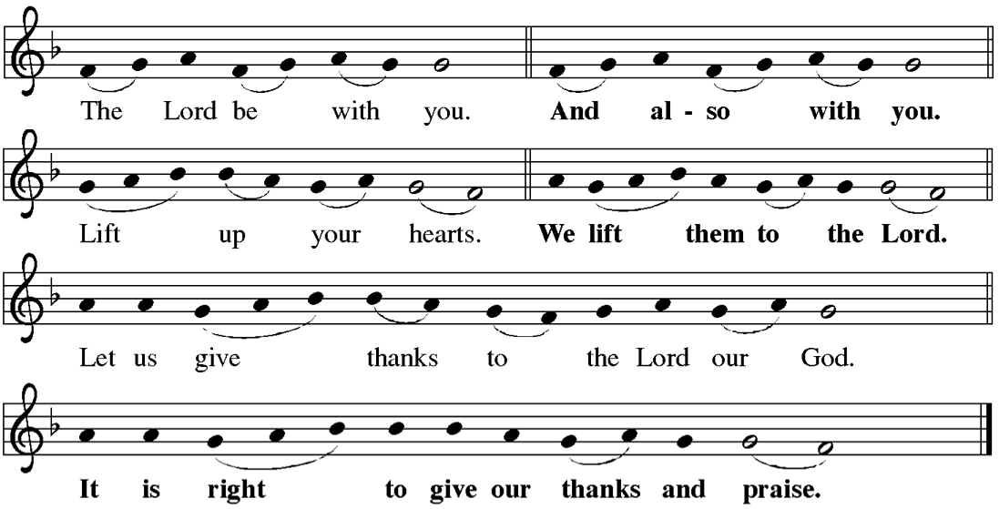

The Proper Preface
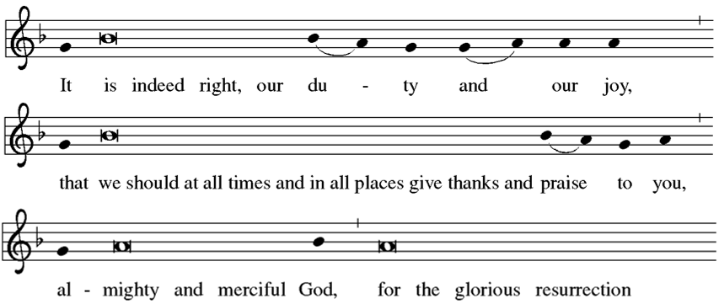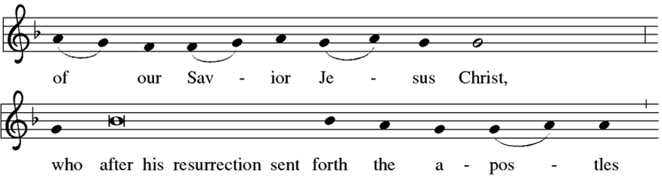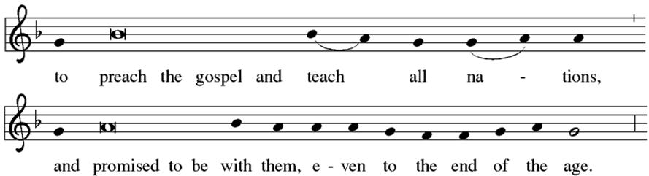


Proper Preface (continuation)

Sanctus
Eucharistic Prayer
Blessed are you, O God of the universe. Your mercy is everlasting and your faithfulness endures from age to age. All creation sings your praise. Sun, moon, and stars reflect your glory. Mountains, lakes, and forests declare your wonders.
With Sarah and Abraham we go out in faith, trusting your promise.
With Miriam and Moses we celebrate our deliverance from bondage.
With Naomi and Ruth we bind ourselves together in covenant love.
With Jonathan and David we delight in the gift of deep and abiding friendship.
With Mary and Elizabeth we welcome your presence in the birth of Jesus, the Holy One.
With Lazarus, Martha, and Mary we give thanks for the blessings of family.
With disciples and followers we marvel at the reign of God come near.
With saints through the ages we ponder the mystery of Christ’s dying and rising.
And so, we remember that, in the night in which he was betrayed, our Lord Jesus took bread and gave thanks; broke it, and gave it to his disciples, saying: Take and eat; this is my body, given for you. Do this for the remembrance of me.
Again, after supper, he took the cup, gave thanks, and gave it for all to drink, saying:
This cup is the new covenant in my blood, shed for you and for all people for the forgiveness of sin. Do this for the remembrance of me.
With hearts full of memories and hopes, we break this bread and share this cup, remembering the death and resurrection of Christ, and his promise to be with us always as we proclaim the mystery of faith.
O Divine Lover, you are the breath within us. You are our heart’s desire. You are our priceless treasure. You are the garden of paradise.
Come down, O Love divine. Come among us, O passionate Fire. Come within us, O Spirit of unity. Come, Holy Spirit. Come, Holy Spirit.
Bless us, O Lord, and these your gifts, which we are about to receive from your bounty.
Bless our table and the feast we share. Bless us with gladness of heart.
Come, Holy Spirit.
At this table make us your body. Form us to be people of justice and peace. Fill us with gratitude and generosity that we may bear the fruit of love in word and deed.
Come, Holy Spirit. Come, Holy Spirit.
Praise to you, Author of creation. Praise to you, O Beloved One. Praise to you, O Giver of all good things. Praise to you, blessed and holy Trinity, one God, now and forever.

Lord’s Prayer
Pastor:
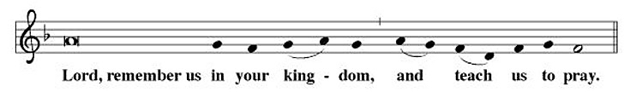
Congregation (A Capella):
Invitation to Communion
Draw near with faith.
Receive the body of our Lord Jesus Christ which he gave for you,
and his blood which he shed for you.
Eat and drink in remembrance that he died for you,
and feed on him in your hearts by faith with thanksgiving.
All are seated.
Lamb of God

Communion


Choir Anthem I Will Not Leave You Comfortless - Everett Titcomb
I will not leave you comfortless,
I will come to you yet again: Alleluia.
And your heart shall be joyful, Alleluia

All stand as able.

Post Communion Blessing
The body and blood of our Lord and Savior Jesus Christ strengthen you and keep you in God’s grace. Amen.

Post Communion Hymn O Life that Flames Forth
Commissioned and Composed for Concordia's 100th Anniversary in 1994
Composed by Allan B. Conway |Text by N.F.S. Grundtvig | Translated by Kim Eric Williams

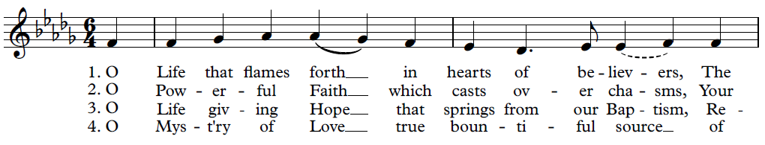
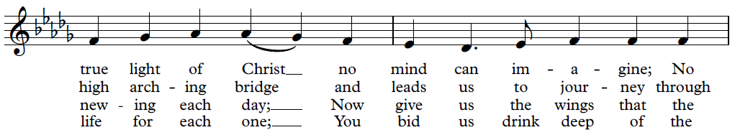
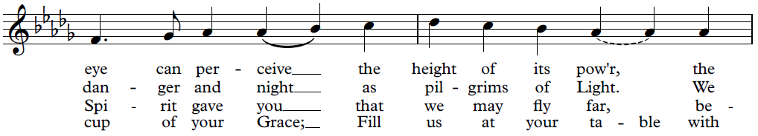
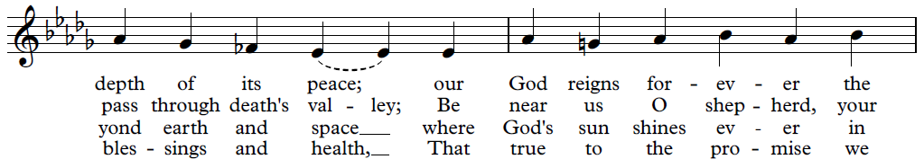
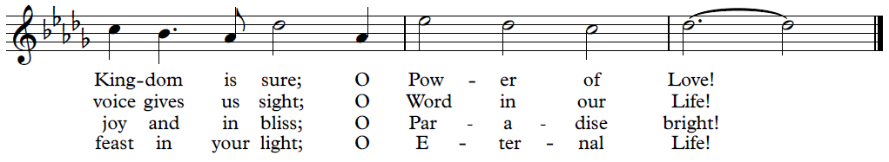

Post Communion Prayer
Let us Pray.
Gracious God, we give you thanks that at your table you have strengthened us for service wherever you will send us.
As we leave this place, welcome us forever into your embrace, until that day when all your people throughout the world worship together around the throne of Jesus Christ, our Savior and Lord.
Amen.
Benediction
Each one of these blessing prayers is based on one of the “gifts of the Holy Spirit.” These divine gifts: wisdom, understanding, counsel, might, knowledge, reverence, and joy, are promised to each child of God through the laying on of hands at baptism. Each blessing will be offered by one of the former pastors of Concordia.
As we are sent forth into the world for love and service,
we ask that God’s blessing may go with us.
May God give you the gift of wisdom that your mind may be illumined and that you may have a wise and loving heart. Amen.
May God give you the gift of understanding that you may comprehend what is the height, depth, majesty, and breadth of God’s love for you. Amen.
May God give you the gift of counsel that you may be a listening ear, a generous giver, and a strong and caring support for others. Amen.
May God give you the gift of might, that with courage and strength you may be a bold champion of the needs of the neighbor and stand against all oppression, war, and fear. Amen.
May God give you the gift of knowledge that you may search for and truly find the pearl of great price. Amen.
May God give you the gift of reverence that you may discern God’s image and likeness in each human you meet and truly honor the diversity and beauty of God’s creation. Amen.
May God give you the gift of joy that your heart may be renewed, that you may laugh with delight at God’s surprising grace, and that you may go forth with a merry spirit to love and serve God and your neighbor as yourself. Amen.
And may the blessing of God, the Father, the + Son, and the Holy Spirit,
Be among you and go with you forever. Amen.
Sending Hymn Now Thank We All Our God
Congregation- verses 1 and 3 Choir Alone – verse 2 ELW 840
Dismissal
Go forth into the world to serve God with gladness; be of good courage; hold fast to that which is good; render to no one evil for evil; strengthen the fainthearted; support the weak; help the afflicted; honor all people; love and serve God, rejoicing in the power of the Holy Spirit.
Thanks be to God.
All are seated.

Postlude “Toccata” from Symphony No. 5 - Charles-Marie Widor
John Anderson, Organ

The Bible texts of the lessons are from the New Revised Standard Version Bible, copyright 1989 by the Division of Christian Education of the National Council of the Church of Christ in the USA, and used by permission.
Selected liturgical texts from Sundays and Seasons.com. Copyright 2015 Augsburg Fortress. All rights reserved. Reprinted by permission under Augsburg Fortress Liturgies Annual License.
Serving in Worship Today:
|

Presiding The Rev. Douglas D. Barclay
Preaching The Rev. JoAnn A. Post
Director of the Liturgy/Deacon Mark L. Winzler
Assisting Deacons Sandy Baranowski | Jeanine Barber
Wendy Donagher | David Smith
Candace Wilson
Organist John Anderson
Choir Director Richard J. Hicks
Assistant Choir Director Rebekka Almond
The Concordia Choir David Almond | Kathi Almond
Jeanine Barber | David Beauregard
Jan Bellino | Rebecca Bourret
Renee Colburn | John Corl
Wendy Donagher | Martha Freimuth
JaneMarie Galiette | Diane Gawlinski
Ed Gawlinski | Patti Herdic
Nancy Lynn Knauff | Finn Lambert
Maureen Leyes | Heidi Lindberg
Leighann Munn | Jenn Oberto
Martin Smith | Lori Spivey
Carol Stoneman | Erich Stoneman
Atrium Brass Quintet Corrine Zanetti | Doug Nemeth, Trumpets
Beth Pratt, Horn
Fred Bagnall, Trombone
James Lendvay, Tuba
Timpanist Honoka Masuyama
Ushers Don and Marian Slater
Acknowledgements

Sincere thanks……

To The Celebration of Ministry Eucharist Planning Team……
- John Anderson (Organist)
- Rebekka Almond (Choir Director)
- The Rev. Douglas D. Barclay (Former Pastor)
- Richard J. Hicks (Minister of Music Emeritus)
- The Rev. JoAnn A. Post (Former Pastor)
- Mark L. Winzler (Council President/Head Deacon)
who lovingly crafted this liturgy. This included selecting the hymns, lessons and other portions of the liturgy, selecting the choir anthems, rehearsing the choir and brass, creating the brass/timpani arrangements for hymns/choir anthems, crafting the Thanksgiving for Baptism, Prayer Intercessions, and Benediction… and the list goes on.

To our former Pastors for their presence and participation in this Celebration of Ministry liturgy:
- The Rev. Douglas Barclay (2015-2020)
- The Rev. Rebecca Bourret (1995-1997)
- The Rev. Dr. Rolf Hedberg (2014-2015 and 2021-2025)
- The Rev. Dr. Martha Klein Larsen (1998-2000)
- The Rev. John Marchhausen (2020-2021)
- The Rev. JoAnn Post (2005-2014)
- The Rev. David Rinas (1974-1977)

To New England Synod Bishop Nathan D. Pipho for his presence and words of welcome.
To former Concordia Choir members and guests for singing with present Concordia Choir members.

To former members of Concordia, friends of Concordia members, town officials, area churches and clergy for their presence.

Notes on Flowers for Today’s Worship
The arrangements were all created with love and care by members and friends of Concordia with the help of Park Hill Florist of Manchester who sourced the flowers. Many of the greens are sourced from the Worship and Memorial Garden and from the grounds of Concordia.
Flowers on the Back Marble Altar
A hedgerow of assorted flowers and greens featuring 132 deep red roses in honor of each year of Concordia’s history. Each rose represents a year of grace and celebrates both the beauty and fragility of our endeavors. It suggests the rich blessing of years and each person touched by the ministry of the congregation.
Chancel Arrangement
The large standing arrangement in the chancel by the main altar is in memory of Barbara Baker, longtime parish worker, whose life of dedicated ministry curated the worship life of the congregation, engaged young people, and helped Concordia to serve the broader Manchester community through MACC.
Pulpit Arrangement
The flowers at the pulpit are in memory and honor of pastors and lay deacons who have served Concordia throughout its history. This stands at the pulpit to honor their ministry of the Word through preaching, proclamation and teaching.
Choir Loft Flowers
The flowers near to the choir loft are in thanksgiving for the music ministry of Concordia and in memory and honor of the musicians, singers, instrumentalists, and all who have shaped Concordia’s worship ministries in its history. It also honors the Austin Pipe Organ, which has faithfully sounded forth, supported hymns, and filled the space with beautiful music for 65 years.
Window Arrangements
Each of the 10 window sills holds a small arrangement. These arrangements honor the many community partnerships and ecumenical relationships that Concordia has been a part of over the years.

